Exergy-based optimization for the synthesis of heat pump assisted distillation columns
Mirko Skiborowskiª*, Kai Fabian Kruberª
ªHamburg University of Technology, Institute of Process Systems Engineering, Am-Schwarzenberg-Campus 3, 21073 Hamburg, Germany
mirko.skiborowski@tuhh.de
Abstract
While distillation columns are the main unit operation in fluid separation processes, considered versatile, robust, and well-understood, they are also oftentimes framed as energy intensive and potentially inefficient. Heat pumps bear the potential to improve the energy efficiency of distillation processes and simultaneously allow for the electrification of the thermal-driven separation processes. However, the economic viability and potential for energy savings depend strongly on the temperature lift and the compression ratio of the heat pump. Both can be reduced by considering intermediate heat exchangers rather than a full temperature lift from below the top vapor to above the bottoms temperature. Such intermediate heat exchangers may furthermore improve the internal efficiency of the distillation column and thereby improve the overall energy efficiency. The current contribution presents an exergy-based optimization that allows for an improved heat load distribution that can provide significant improvements of the internal efficiency and further enables a conceptual design of heat pump assisted distillation, using vapor recompression to provide the heat loads at the intermediate heat exchangers. The benefits of the approach are illustrated for the separation of a nonideal acetone-water mixture, highlighting the capability to identify unintuitive designs with significant saving potential.
Keywords: conceptual design, distillation, exergy, heat pumps, optimization
  - Introduction
Since distillation columns are not only the most frequently applied fluid separation technology in the chemical industry but also responsible for the majority of the thermal energy demand, they provide substantial improvement potential in the pursuit of a net-zero emissions production by 2050. Heat pumps are considered as one of the most important technologies in the transition to renewable energy sources, which also provide the potential to transform thermally-driven distillation columns to electrically-driven heat pump assisted distillation columns (Kiss et al., 2020). Consequently, heat pumps are considered as key to the desired electrification of the chemical industry. While significant advancements in the performance and applicability range of heat pumps have been made in recent years, the underlying concept and its application to distillation columns had already received considerable attention after the oil crisis in the 1980s (Gopichand et al., 1988).
Yet, a proper set of tools for identifying the best suitable configurations of heat pump assisted distillation is not easily available, despite a variety of publications dealing with the evaluation and optimization of specific process configurations, including the most popular mechanical vapor recompression (VRC) and the most complex internally heat integrated distillation columns (HIDiC). A HIDiC combines the concept of VRC and diabatic distillation, pursuing a continuous heat transfer from the rectifying to the stripping section, by operating the whole rectifying section at an increased pressure. Although this concept bears theoretically huge potential for improving the energy efficiency of the distillation-based separation, it has been shown that comparable energy savings can be achieved by much simpler process configurations, potentially exploiting just a single heat exchanger (Harwardt et al., 2012). Further constraints on the alignment of the temperature profiles present additional limitations for the HIDiC concept (Shenvi et al., 2011). In order to evaluate the potential of heat pump assisted distillation either simplified heuristics, such as sufficiently small boiling point differences (Kiss et al., 2012), dedicated simulation studies by means of commercial flowsheet simulators (e.g. Rix et al. 2023), or more advanced optimization models (Harwardt et al., 2012) can be applied. So far, a simple tool for a quick identification of the best-suited integration of one or multiple heat pumps and a distillation column by means of a quantitative assessment is not available.
In order to overcome this limitation, an exergy-based optimization is proposed, which identifies the most promising locations for intermediate heat transfer to increase the internal efficiency of the distillation column. The resulting locations provide an excellent indication for the proper placement of heat pumps, which is further demonstrated for heat pump assisted distillation employing mechanical VRC. The optimization-based approach is able to identify even unconventional configurations that offer large improvements for the separation of nonideal mixtures and provides a simple tool that can easily be transferred to common process flowsheet simulation software to strategically identify suitable heat pump modifications for the electrification of distillation columns. The application of the method is illustrated for the separation of an acetone-water mixture, considering the full range of feed compositions.
  - Method
The proposed screening approach builds on different calculations and tools to perform a time-efficient evaluation of possible improvements with respect to energy efficiency and the identification and evaluation of a suitable heat pump assisted distillation process. Shortcut-based evaluation of the minimum energy demand (MED) and the vapor compression heat pumps are performed in MATLAB®, while a multi-stage MESH model in GAMS is used for the exergy-based optimization. Finally, a simulation model in Aspen Plus® is used for the validation of the results.
    - Evaluation of energy efficiency
The energy efficiency of a separation process is determined in accordance with the description provided by Gooty et al. (2021) as
$$η_{sep}=\frac{W_{min}}{W_{sep}},$$ | (1)
based on the actual work for the separation ($W_{sep}$) and the minimum work
$$W_{min}=D\left(h_{D}-T_{0}s_{D}\right)+B\left(h_{B}-T_{0}s_{B}\right)-F\left(h_{F}-T_{0}s_{F}\right),$$ | (1)
with specific enthalpy ($h$) and entropy ($s$) of the products with flowrate ($D,B$) and feed stream ($F$) at reference conditions ($T_{0},p_{0}$). These are taken as 25 °C and 1 atm in the current study. In accordance with the work of Gooty et al. (2021), it is further assumed that product cooling compensates for feed heating, assuming an ideal heat integration with zero exergy losses. The analysis of the energy efficiency therefore focuses on the internal efficiency of the distillation column, which can be calculated from the equivalent exergy of all heat duties provided at vanishing temperature difference and the external efficiency, which considers the actual temperature of the utilities or the power that is required to drive the compressor for the computation of the separation work
$$W_{sep}=\sum{Q}\left(1-\frac{T_{0}}{T}\right)+\sum{W_{comp}}.$$ | (3)
    - Shortcut screening for energy efficiency rating of simple distillation columns
For an initial evaluation of the energy efficiency of simple distillation columns the minimum energy demand (MED) is analyzed based on the pinch-based rectification body method (RBM) (Bausa et al. 1998). The RBM does not rely on simplifying assumptions like constant molar overflow and constant relative volatility and checks for tangent pinches, which is of special importance for non-ideal systems, such as the investigated acetone-water system.
    - Shortcut evaluation of heat pump performance
Based on the heat loads for condensation and evaporation, as well as the composition and temperature of the respective streams an isentropic compression cycle is considered for the evaluation of a possible heat pump implementation. The required compression ratio (CR) is determined by bisection, evaluating the boiling temperature of the compressed stream by individual flash calculations. Enthalpy checks are used to identify the need for an additional supersaturation prior to the compressor. The minimum workload is determined based on an isentropic compression with an efficiency of 80% and mechanical efficiency of 90%. In case the compressed vapor does not provide a sufficient heat load for the evaporation, the remaining heat is provided by an additional steam-heated reboiler. The performance of the heat pump is characterized by the coefficient of performance (COP) and an estimate of cost savings, considering the investment for the compressor with a depreciation of 3 years and an interest rate of 6%, as well as the cost for 3 bar steam (3.3 ct/kWh) and electricity (6 ct/kWh). The equipment costs are estimated for a single stage centrifugal compressor according to Biegler et al (1997).
    - Exergy-based optimization for improved energy efficiency
In order to improve both the internal and external efficiency of the distillation column, a multistage MESH model of the distillation column with the possibility of intermediate heating or cooling at dedicated stages in the rectifying and stripping section is optimized in GAMS. The model used for the optimization builds on the model formulation and initialization strategy of Skiborowski et al. (2015) and is optimized for a column with 80 equilibrium stages and possible intermediate heating or cooling at stage 20 or 60 with the objective to minimize the actual separation work ($\min_{Q_{i}}{W_{sep}}$).
    - Process concept validation
The performance calculations and optimization results are exemplarily validated by rigorous simulation studies in Aspen Plus® based on the included RadFrac and compressor model. The results are evaluated based on the previously computed reboiler duty, reflux ratio, as well as target values for the heat duties of the two intermediate heat exchangers. The latter are achieved by varying the amount of compressed top vapor in both compressors by two design specifications. The RadFrac model is defined in accordance with the optimization model in GAMS, considering 80 equilibrium stages with the feed entering on stage 40 and intermediate heating on stages 20 and 60.
  - Results
In order to illustrate the potential of the proposed exergy-based optimization approach, the separation of the nonideal acetone-water mixture is investigated for varying feed compositions. The thermodynamic model considers the non-random two-liquid (NRTL) activity coefficient model for the liquid phase, the Redlich-Kwong equation of state for the fugacity coefficients of the vapor phase, as well as DIPPR correlations for the specific heat capacities and the heat of evaporation. The respective property model parameters are taken from Skiborowski et al. (2014).
    - Shortcut screening for energy efficiency rating
The shortcut-based evaluation of the MED is performed for feed compositions ranging from 2 mol% up to 98 mol% of acetone with an increment of 1 mol%, considering a feed flow rate of 10 mol/s and product purities of 99.5 mol% each. The internal and external efficiency for these separations are determined based on the heat duties and product streams as described in Section 2.1, while the potential for VRC is evaluated based on the isentropic compression cycle as described in Section 2.3. The resulting efficiencies are illustrated in Figure 1 as black, red, and blue solid lines. Obviously, these lines all deviate significantly from the bell-shaped efficiency curves, with maximum efficiencies close to a symmetrical feed composition, that are usually reported for closely ideal systems, as e.g., illustrated in the work of Gooty et al. (2021). This deviation is primarily caused by the tangent pinch in the rectifying section, which controls the MED. While internal efficiencies close to 40% are still feasible for feed compositions with low acetone composition, the internal efficiency drops below 10% for feed compositions above 70 mol% of acetone. More noticeably, external efficiencies for conventional steam heating and wasting the condensation heat to cooling water already drop below 10% at a feed composition of 20% acetone. The energy efficiency of the simple column with VRC is raised considerably, but also drops below 10% for acetone feed compositions above 35 mol%. These VRC applications are also not economically favourable, resulting in considerably increased cost for the 3-year period, which fits to expectations considering the boiling point difference of about 40 K (Kiss et al. 2012). Obviously, simple distillation columns are rather inefficient for this separation, especially for feed compositions that are richer in acetone composition.
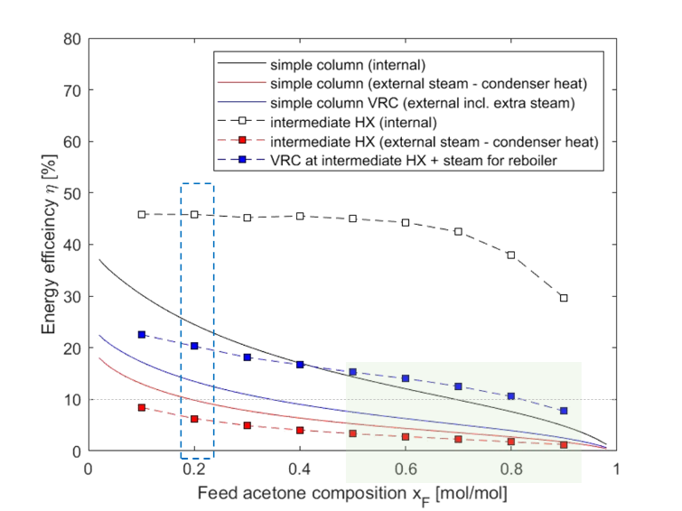
Figure 1: Illustration of the internal and external energy efficiency of simple and complex distillation columns with and without VRC.
    - Exergy-based optimization for improved energy efficiency
In order to evaluate the potential for improved energy efficiency by means of intermediate heating, exergy-based optimizations are performed for feed compositions with 10-90 mol% of acetone with increments of 10 mol%. The resulting internal and external efficiencies are also illustrated in Figure 1 as black, red, and blue square symbols, connected by an interpolated dashed line. The intermediate heating enables a substantial increase of the internal efficiency to more than 40% for acetone feed compositions up to 70 mol%. As the improved internal efficiencies are yielded with an increased MED, the respective external efficiencies with steam-based heating drop even below the external efficiencies of the simple column. However, applying VRC for the intermediate heat exchangers, the potential of the increased internal efficiency can be exploited, leading to external efficiencies above the internal efficiency of the simple columns for acetone feed compositions above 45 mol%.
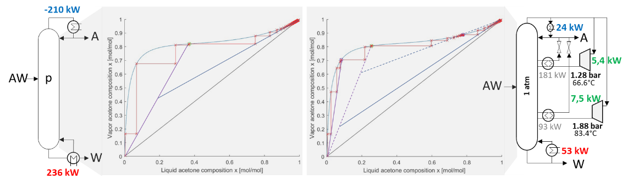
Figure 2: Resulting energy distribution and stage profiles for the simple (left) and complex column with intermediate heat exchangers (right) for a feed with 20 mol% of acetone. Indicated operating lines are approximations based on true stage profiles.

For further elucidation the results of the conceptual design for the simple and complex column are illustrated in Figure 2 for a feed composition with 20 mol% acetone. The simple column requires a reboiler duty of 236 kW, governed by the tangent pinch in the rectifying section. A VRC design with a CR of 3.7 and a COP of 5.5 could compensate most of the heat duty with a power requirement of 36 kW, but would result in a 30% cost increase for the 3-year period. This fits the expectations, given the temperature lift of more than 40 K. In contrast, the complex column with intermediate heat exchangers can compensate for most of the heat requirements by VRC with the intermediate heat exchangers with a cumulative power requirement of only 13 kW. The compressors operate at CRs of 1.3 and 1.9 and yield COP values of 33 and 12, respectively. Both heat pumps enable cost savings within the 3-year period, with 70% and 20% each. Comparing the stage profiles of the simple and complex column, it is apparent that the maximum distance between the operating line and the vapor-liquid equilibrium line is much lower for the complex column, reflecting the reduced exergy losses. A very important aspect in the derived design is that interstage heating is performed in the stripping and the rectifying section. The latter allows for heat integration at a minimum temperature lift but is certainly an extremely unconventional design, or as expressed by Agrawal and Fidkowski (1996) “against the widely accepted, normal distillation practise”. The results of the conceptual design are further validated by Aspen Plus® simulations (cf. Section 2.5). The results for the exemplary 20 mol% acetone feed are in excellent agreement, even yielding a slight increase of 2% points in terms of the energy efficiency.
  - Conclusions
The systematic analysis of energy efficiency and exergy-based optimization allow for the derivation of efficient VRC designs with intermediate heat exchangers that can enable external efficiencies above the internal efficiencies of simple distillation columns. The case study highlights the potential to automatically identify unconventional designs, including the illustrated interstage heating in the rectifying section. While we could not find any prominent example of such configurations in publications in the last 20 years, the first indication of such configurations date back to Lynd and Grethlein (1986), who introduced the concept as intermediate heat pumps and optimal side stream return distillation, illustrating the case of a tangent pinch separation for an ethanol-water system. It is probably the most interesting feature of the current approach that it automatically identifies such a rarely known configuration, which obviously contradicts common design heuristics. Future work will extend the method to yield a superstructure-based economic optimization, building on the work of Waltermann and Skiborowski (2019) and exploit pressure variations as proposed by Rix et al., 2023.
Acknowledgement
Gefördert durch die Deutsche Forschungsgemeinschaft (DFG) —523327609 / funded by the Deutsche Forschungsgemeinschaft (German Research Foundation) — 523327609.
References
R. Agrawal, Z.T. Fidkowski, 1996, On the use of intermediate reboilers in the rectifying section and condensters in the stripping section of a distillation column, Ind. Eng. Chem. Res., 35, 2801-2807
L. Biegler, I.E. Grossmann, A. Westerberg, 1997, Systematic methods of chemical process design, Prentice Hall, Hoboken
J. Bausa, R. von Watzdorf, W. Marquardt, 1998, Shortcut methods for nonideal multicomponent distillation: 1. Simple columns, AIChE J., 44 (10) 2181-2198
S. Gopichand, 1988, Heat pump assisted distillation. X: Potential for industrial applications, Int. J. of Energy Research, 12, 569-582
A. Harwardt, W. Marquardt, 2012, Heat-integrated distillation columns: Vapor recompression or internal heat integration?, AIChE J., 58, 12, 3740-3750
T. Kiss, S.J. Flores Landeata, C.A. Infante Ferreira, 2012, Towards energy efficient distillation technologies – Making the right choice, Energy, 47, 531-542
T. Kiss, R. Smith, 2020, Rethinking energy use in distillation processes for a more sustainable chemical industry, Energy, 203, 117788
L.R. Lynd, H.E. Grethlein, 1986, Distillation with intermediate heat pumps and optimal sidestream return, AIChE J., 32 (8), 1347-1359
A. Rix, M. Schröder, N. Paul, 2023, Vapor recompression: An interesting option for vacuum columns?, Chem. Eng. Res. Des., 191, 226-235
A.A. Shenvi, M. Herron, R. Agrawal, 2011, Energy efficiency limitations of the conventional heat integrated distillation column (HIDIC) configuration for binary distillation, Ind. Eng. Chem. Res., 50, 119-130
M. Skiborowski, J. Wessel, W. Marquard, 2014, Efficient optimization-based design of membrane-assisted distillation processes, Ind. Eng. Chem. Res., 53, 15698-15717
M. Skiborowski, A. Harwardt, W. Marquard, 2015, Efficient optimization-based design for the separation of heterogeneous azeotropic mixtures, Comp. Chem. Eng., 34, -51
T. Waltermann, M. Skiborowski, 2019, Efficient optimization-based design of energy-integrated distillation processes, Comp. Chem. Eng., 129, 106520

